Aim: Create Application by Using Building Blocks for Android Application Design (Linear Layout).

Theory:
Android LinearLayout is a view group that aligns all children in either vertically or horizontally.
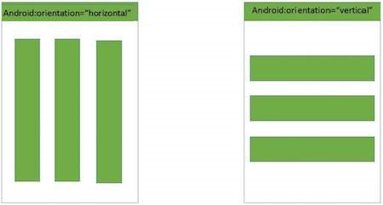

Source code:

MainActivity.java

package com.example.demo;

import android.os.Bundle;
import android.app.Activity;

public class MainActivity extends Activity {
@Override
protected void onCreate(Bundle savedInstanceState) {
super.onCreate(savedInstanceState);
setContentView(R.layout.activity_main);
}
}
Following will be the content of res/layout/activity_main.xml file −
<?xml version="1.0" encoding="utf-8"?>
<LinearLayout xmlns:android="http://schemas.android.com/apk/res/android"
android:layout_width="fill_parent"
android:layout_height="fill_parent"
android:orientation="vertical" >

<Button android:id="@+id/btnStartService"
android:layout_width="270dp"
android:layout_height="wrap_content"
android:text="start_service"/>

<Button android:id="@+id/btnPauseService"
android:layout_width="270dp"
android:layout_height="wrap_content"
android:text="pause_service"/>

<Button android:id="@+id/btnStopService"
android:layout_width="270dp"
android:layout_height="wrap_content"
android:text="stop_service"/>

</LinearLayout>

Following will be the content of res/values/strings.xml to define two new constants −
<?xml version="1.0" encoding="utf-8"?>
<resources>
<string name="app_name">HelloWorld</string>
<string name="action_settings">Settings</string>
</resources>

Output:
